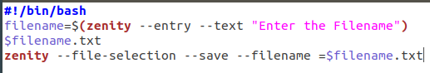
MUHAMMAD HASSAN KHAN FA17-BECE-0008
LAB 12
TASK01
CODE

EXECUTION

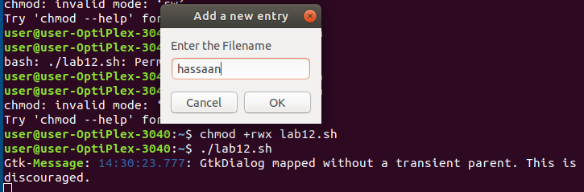
OUTPUT
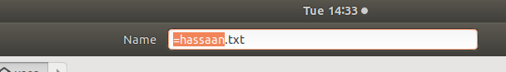

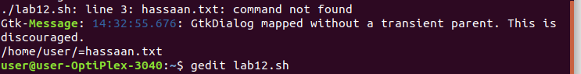

TASK02
CODE
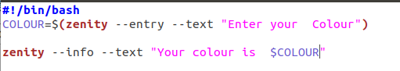

Execution
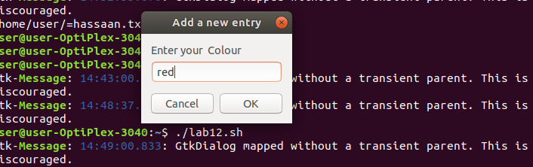

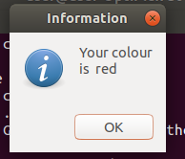
OUTPUT

TASK03

CODE

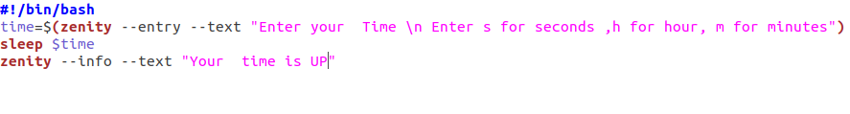

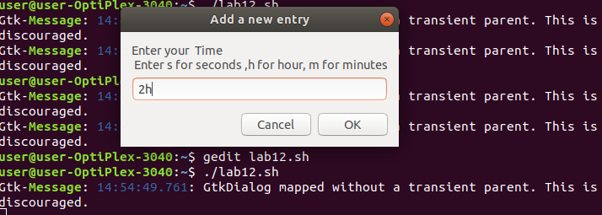
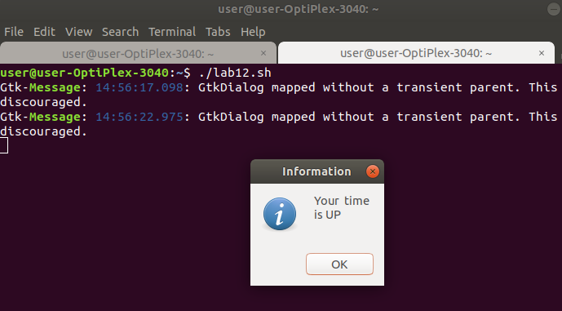
Execution

OUTPUT

